Project Design Phase-II
Technology Stack (Architecture & Stack)

Date | 15 July 2026
Team ID
Project Name | Car Booking
Maximum Marks | 4 Marks

Technical Architecture:
The Ucab Cab Booking Application follows a three-tier architecture built using the MERN Stack (MongoDB, Express.js, React.js, and Node.js). This architecture separates the presentation layer, business logic layer, and data layer, making the application modular, scalable, secure, and easy to maintain.

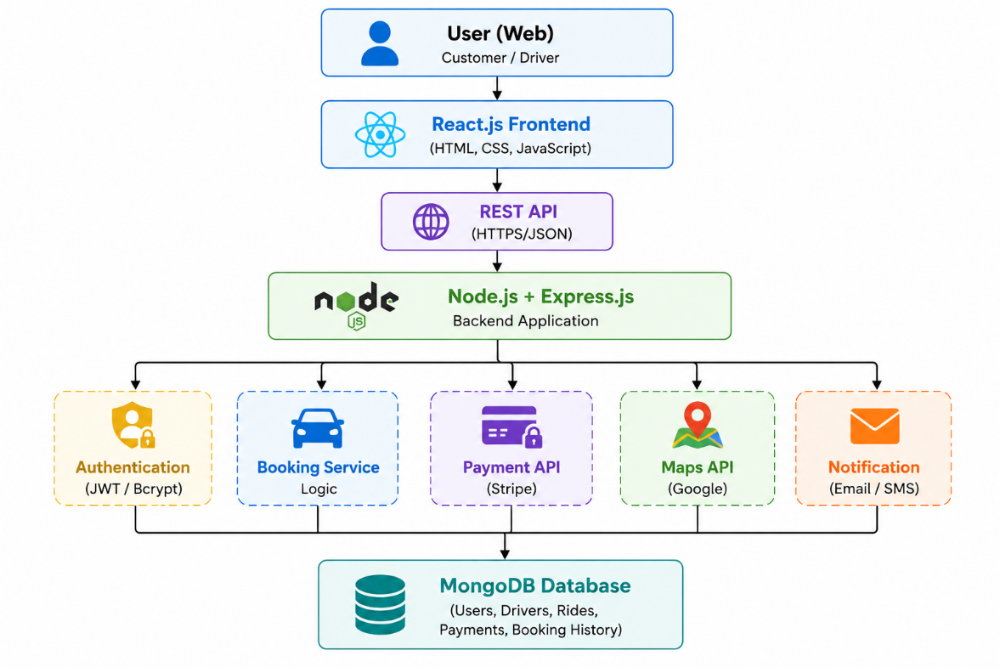

Table-1 : Components & Technologies:
S. No | Component | Description | Technology
 | User Interface | Web application for customers and drivers | HTML5, CSS3, JavaScript, React.js
 | Application Logic-1 | User authentication, cab booking, ride management | Node.js, Express.js
 | Application Logic-2 | Fare calculation, driver allocation, booking history | JavaScript (Node.js)
 | Application Logic-3 | Real-time ride tracking and notifications | Socket.IO, Express.js
 | Database | Stores users, drivers, bookings, payments | MongoDB
 | Cloud Database | Cloud-hosted MongoDB database | MongoDB Atlas
 | File Storage | Driver profile images and documents | Local File System / Cloudinary
 | External API-1 | Live maps, navigation, location services | Google Maps API
 | External API-2 | Online payment processing | Stripe API / Razorpay API
 | Machine Learning Model | Cab demand prediction and route optimization (future enhancement) | TensorFlow / Scikit-learn (Optional)
 | Infrastructure (Server / Cloud) | Application deployment | Local Server, Render, Railway, Vercel

Table-2: Application Characteristics:
S. No | Characteristics | Description | Technology
 | Open-Source Frameworks | Frontend and backend development frameworks | React.js, Node.js, Express.js, MongoDB
 | Security Implementations | Secure authentication, encrypted passwords, protected APIs | JWT Authentication, Bcrypt Password Hashing, HTTPS, CORS
 | Scalable Architecture | Three-tier architecture separating frontend, backend, and database | MERN Stack, REST APIs
 | Availability | Cloud deployment with reliable database services | MongoDB Atlas, Render/Vercel
 | Performance | Fast API response, optimized queries, client-side rendering | React Virtual DOM, Express.js, MongoDB Indexing, Caching

Architectural Benefits
- Modular three-tier architecture for better maintainability.
- Secure communication through HTTPS and JWT authentication.
- Scalable backend capable of handling increasing user requests.
- Efficient NoSQL database for flexible and fast data management.
- Integration with external APIs for maps, payments, and notifications.
- Cloud-ready deployment for improved reliability and availability.
- Easy future integration of advanced features such as AI-based ride prediction, dynamic pricing, and ride-sharing.

